[IMAGE COMPRESSION]
(Compressed Bitmap Image, CBI format)

Hello User, I am Suman Debnath, programmer of the codes, here presenting you some tips & help.

1) This project is only for UNIX platform (I have used Red Hat Linux, Kernel 2.4), because it needs a huge resource that DOS can not provide.
2) You just have to run the shell script run.sh [command➔ sh run.sh in UNIX console].
3) For simplicity, at first, you keep all the three codes and a sample bmp file in same folder, then run the project.
4) The project is designed only for GREY level BITMAP images. So if you have a color image then convert it into a grey bitmap image by any software before using as an input in the project.
5) Do not use an image having large resolution (more than 1200x1200) or file size more than 1.5 MB.
6) You will have to decompress CBI file to BMP file to view that.

Please Reply Me Whether My Effort Is Useful or Not, You Can Freely Modify The Codes, But Please Send Me A Copy After Modifying.
Email: debnath.suman@yahoo.co.in
Mobile: (+91) 9433734317
Thank you for using my first UNIX platform project,
------------------- Suman Debnath
CSE, 2003-2007 Batch
Academy Of Technology
Hooghly, West Bengal, India.
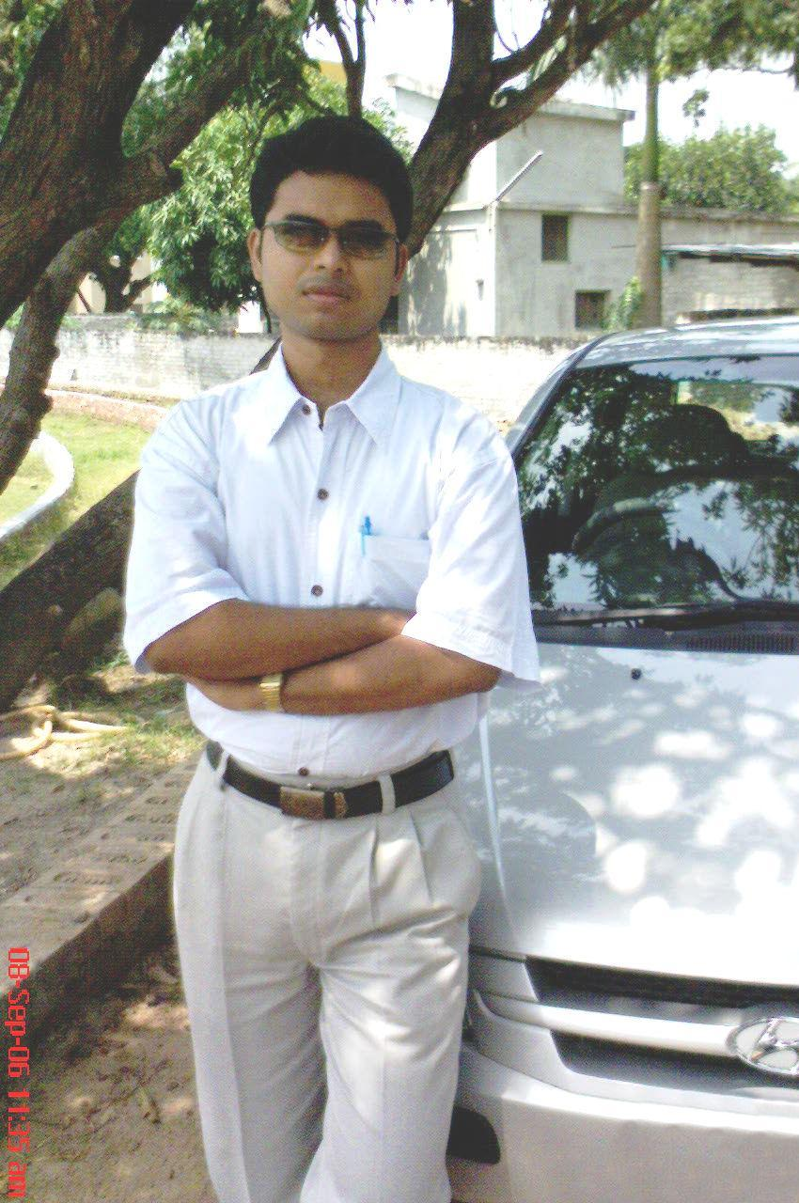
Warning: For Some Images, My Program May Not Work (output is like black-white TV without any channel), I Am Working For That.

